Chapter 13, Problem 32.

Two linear transformers are cascaded as shown in Fig. 13.100. Show that

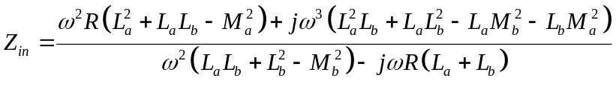

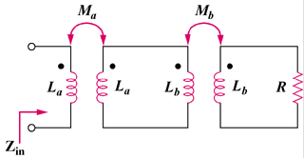

Figure 13.100
For Prob. 13.32.

